How Brachytherapy Works: Exploring Its Role in Cancer Treatment – H1
P1 | what is brachytherapy
P2 | types of brachytherapy
P2 | benefits of brachytherapy
P1 | internal radiation therapy
P2 | brachytherapy benefits
P2 | best oncologist in pune

URL Slug: /how-brachytherapy-works-cancer-treatment
Title: How Brachytherapy Works in Cancer Treatment
Description: Brachytherapy is a precise internal radiation treatment for cancer. Learn about its types, benefits, and why it's preferred for certain cancer treatments.
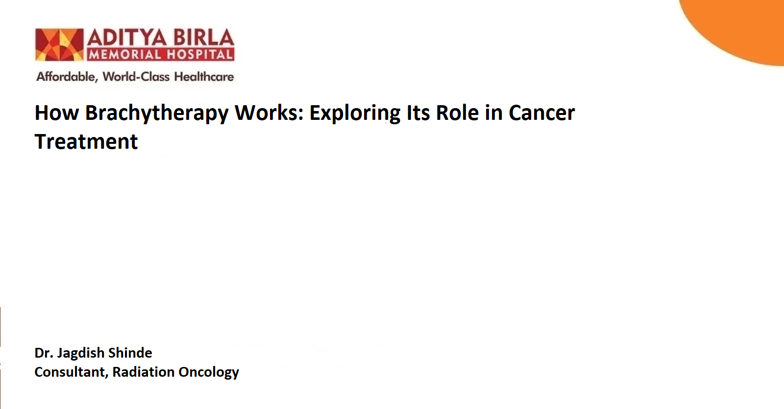

Cancer treatment has evolved significantly over the years, with a range of advanced therapies available to improve outcomes for patients. Among these, brachytherapy stands out as a precise and effective form of internal radiation therapy. This guide explores what brachytherapy is, the different types of brachytherapy, its benefits, and why it is a preferred option in specific cancer treatments.
What Is Brachytherapy? - H2
Brachytherapy, also known as internal radiation therapy, involves placing a radiation source directly inside or near the tumour. Unlike external beam radiation therapy, which delivers radiation from outside the body, brachytherapy allows for a highly localized and concentrated dose of radiation to target cancer cells while minimizing damage to surrounding healthy tissues.
This technique is commonly used to treat cancers of the:
- Prostate
- Cervix
- Breast
- Skin
- Oesophagus

How Brachytherapy Works - H2
The procedure involves placing radioactive materials, such as seeds, ribbons, or wires, inside or near the tumour site. These radioactive sources emit radiation over a specified period, destroying cancer cells and preventing their growth. The duration and intensity of the radiation depend on the type and stage of cancer being treated.
Types of Brachytherapy - H2
Brachytherapy is classified based on the placement of the radiation source and the duration of exposure. The main types include:
1. Low-Dose Rate (LDR) Brachytherapy - H3
- How It Works: Radioactive seeds are placed inside or near the tumor and left for a period ranging from hours to days.
- Common Applications: Prostate and cervical cancers.
- Key Advantage: Continuous delivery of radiation over an extended period.
2. High-Dose Rate (HDR) Brachytherapy - H3
- How It Works: A high-intensity radioactive source is temporarily placed inside or near the tumour for a short duration, often minutes.
- Common Applications: Breast, cervical, and skin cancers.
- Key Advantage: Shorter treatment sessions and precise control of radiation delivery.

3. Permanent Brachytherapy - H3
- How It Works: Small radioactive seeds are implanted permanently within the tumour.
- Common Applications: Prostate cancer.
- Key Advantage: Seeds deliver radiation over time and eventually become inactive, eliminating the need for removal.
4. Temporary Brachytherapy -H3
- How It Works: Radioactive materials are placed for a specific duration and removed once the treatment is complete.
- Common Applications: Various cancers, including cervical and esophageal cancers.
- Key Advantage: Controlled radiation exposure tailored to the patient’s needs.
Benefits of Brachytherapy - H2
Brachytherapy offers several advantages over other cancer treatments, making it a preferred choice for certain types of cancers. These benefits include:
1. Precision - H3
Radiation is given directly to the area of Tumour, without effecting the healthy tissues and organs around.
2. Shorter Treatment Time - H3
Compared to external radiation therapy, brachytherapy often requires fewer treatment sessions.
3. Reduced Side Effects - H3
The localized nature of the therapy minimizes side effects such as fatigue, skin irritation, and organ damage.
4. High Effectiveness - H3
Brachytherapy is highly effective in controlling and eradicating localized tumours, often leading to better outcomes.
5. Versatility - H3
Suitable for treating a wide range of cancers, including prostate, cervical, breast, and skin cancers.
6. Convenience - H3
Outpatient procedures are common, allowing patients to return home the same day in many cases.
The Brachytherapy Procedure - H2
The procedure typically involves the following steps:
1. Pre-Treatment Planning - H3
Imaging tests, such as CT scans, MRIs, or ultrasounds, are performed to map the tumour’s size, shape, and location.
A treatment plan is developed to determine the appropriate type and dose of radiation.
2. Placement of Radioactive Material - H3
Depending on the cancer type and treatment plan, radioactive materials are placed inside or near the tumour using specialized applicators or needles.
Imaging guidance ensures precise placement.
3. Radiation Delivery - H3
Radiation is delivered over a predetermined duration, either continuously (LDR) or in sessions (HDR).
4. Post-Treatment Care - H3
Patients may need follow-up appointments to monitor recovery and assess treatment effectiveness.
Side Effects of Brachytherapy - H2
While brachytherapy is generally well-tolerated, some side effects may occur depending on the treatment site and type. Common side effects include:
- Localized Pain or Discomfort: At the site of radioactive material placement.
- Swelling or Bruising: Temporary and resolves over time.
- Urinary Symptoms: Increased frequency or discomfort in patients undergoing prostate cancer treatment.
- Vaginal Discharge: In cervical cancer treatment.
- Fatigue: Mild and typically short-lived.
- Brachytherapy Benefits vs. External Radiation Therapy

Brachytherapy is often compared to external beam radiation therapy (EBRT). While both are effective, brachytherapy offers unique advantages:
- Higher Radiation Dose: Delivered directly to the tumor.
- Fewer Side Effects: Surrounding tissues are less affected.
- Shorter Duration: Many treatments can be completed in a single session.
However, the choice between brachytherapy and other treatments depends on factors such as cancer type, stage, and patient health.
Why Choose Brachytherapy? - H2
Brachytherapy is a versatile and effective treatment for localized cancers. It is particularly beneficial for patients seeking:
- Targeted treatment with minimal side effects.
- A quicker recovery and return to daily activities.
- High precision and control over radiation delivery.
The Future of Brachytherapy - H2
With continuous advancements in medical technology, brachytherapy is becoming even more precise and effective. Innovations such as image-guided brachytherapy (IGBT) and 3D treatment planning are enhancing the accuracy of radiation delivery, improving patient outcomes, and reducing side effects.
Conclusion - H2
Brachytherapy represents a significant advancement in cancer treatment, offering a targeted and effective approach to managing localized tumours. Its precision, reduced side effects, and shorter treatment durations make it a preferred option for many patients. If you or a loved one are exploring treatment options for cancer, consult a specialist to determine whether brachytherapy is the right choice. With the right care and advanced treatment techniques, you can achieve better outcomes and an improved quality of life.
If you looking for the best oncologist in Pune for brachytherapy, visit Aditya Birla Memorial Hospital, home to some of the best cancer specialists. We offer facilities equipped with state-of-the-art technology and skilled medical professionals ensure optimal outcomes for patients.

Frequently Asked Questions (FAQs) - H2
- How is brachytherapy different from external radiation therapy?
Brachytherapy involves placing radioactive material directly inside or near the tumour, allowing for more precise radiation delivery with minimal impact on surrounding healthy tissues. In contrast, external radiation therapy delivers radiation from outside the body, which may affect a broader area.
- Is brachytherapy a standalone treatment, or is it combined with other therapies?
Brachytherapy can be used alone or in combination with other treatments like external radiation, chemotherapy, or surgery, depending on the cancer type and treatment plan.
- How long does a brachytherapy procedure take?
The duration varies depending on the type of brachytherapy. High-dose rate (HDR) sessions may take minutes and are typically done on an outpatient basis, while low-dose rate (LDR) treatments may require hospital stays of up to a few days.
- Are there any long-term risks associated with brachytherapy?
Long-term risks are generally low but may include localized tissue damage, fibrosis, or changes in organ function near the treatment area. Regular follow-ups help monitor and manage these risks.
- Can brachytherapy be used for paediatric cancers?
Brachytherapy is less commonly used in children but may be considered in specific cases of localized cancers where precision is crucial and surrounding healthy tissues need protection.
- Is brachytherapy painful?
The procedure itself is usually not painful, as it may involve anaesthesia or sedation. However, some patients may experience temporary discomfort or localized pain after the treatment.
References:
1. Williams VM, Kahn JM, Thaker NG, Beriwal S, Nguyen PL, Arthur D, et al. The Case for Brachytherapy: Why It Deserves a Renaissance. Advances in Radiation Oncology [Internet]. 2020 Nov 6;6(2):100605. Available from: https://www.ncbi.nlm.nih.gov/pmc/articles/PMC7940781
2. Skowronek J. Current status of brachytherapy in cancer treatment - short overview. Journal of contemporary brachytherapy [Internet]. 2017;9(6):581–9. Available from: https://www.ncbi.nlm.nih.gov/pmc/articles/PMC5808003/

